City and County of Swansea Dinas A Sir Abertawe
CRWYS PRIMARY SCHOOL
Chapel Road, Three Crosses, Swansea SA4 3PU

Headteacher: Mr. P.A. Withey
( & Fax (01792) 872473
e-mail:crwys.primary@swansea-edunet.gov.uk website:crwyspupils.ik.org

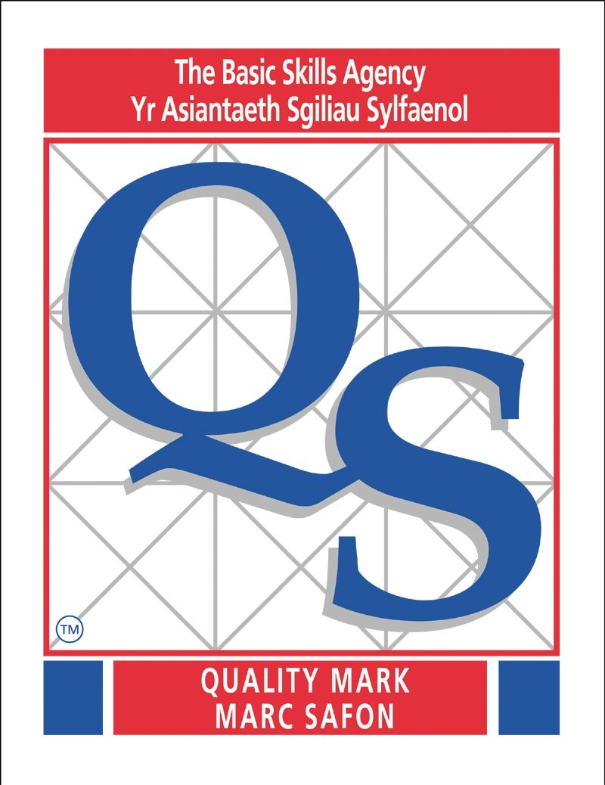

17th September 2014

Dear Parent/Guardian

The children in Year 5 and Year 6 will have the opportunity to visit the Dylan Thomas Theatre for a Performance by Theatre NaNog and then on to Swansea Museum on Tuesday 23rd September 2014. This visit is being organised by Mr Short.

A coach will leave the school at 9.00am and the children will return by the end of the school day. A packed lunch is required for this visit (no glass bottles please). School uniform should be worn for this visit.

It is necessary for us to ask for a voluntary contribution of £8.00 per pupil to cover the transport costs. No parent is obliged to pay this cost, and no child may be prevented from participating in the visit due to non-payment, but you will appreciate that certain costs are involved and if there is not sufficient response then the visit may have to be cancelled. The parental consent form attached should be returned to the school by Monday 22nd September 2014. This is a necessary requirement and we regret that if this form is not returned to school your child will be unable to take part

Yours sincerely

P Withey
Headteacher



Swansea Schools Recycling Gold Award

City and County of Swansea Dinas A Sir Abertawe
CRWYS PRIMARY SCHOOL
Chapel Road, Three Crosses, Swansea SA4 3PU

P A R E N T A L C O N S E N T

Activity/Visit: Dylan Thomas Theatre/Swansea Museum

Date: Tuesday 23rd September 2014

Cost: £8.00

Name of Pupil: …………………………………………………..

Having received information on the proposed Activity/Visit, I consider that the above-named pupil is physically capable of undertaking the activities described and I hereby agree to his/her taking part.

I hereby consent to any medical, dental or surgical treatment, including the administration of an anaesthetic, which may be considered necessary for the above named.

Signed: ..................................................................... (Parent/Guardian)

Date: .........................................

Address:..........................................................................................................

Telephone :............................(Home)..........................................................(mobile)

Alternative address and telephone number to be contacted in an emergency:

......................................................................................................................

IF YOUR SON/DAUGHTER REQUIRES REGULAR MEDICAL TREATMENT FOR ANY ILLNESS OR DISABILITY, PLEASE TICK IN THE BOX BELOW AND GIVE DETAILS OVERLEAF
◻

This is a statutory letter, which we are obliged to send to parents, on the instruction of The City and County of Swansea.

