City and County of Swansea Dinas A Sir Abertawe
CRWYS PRIMARY SCHOOL
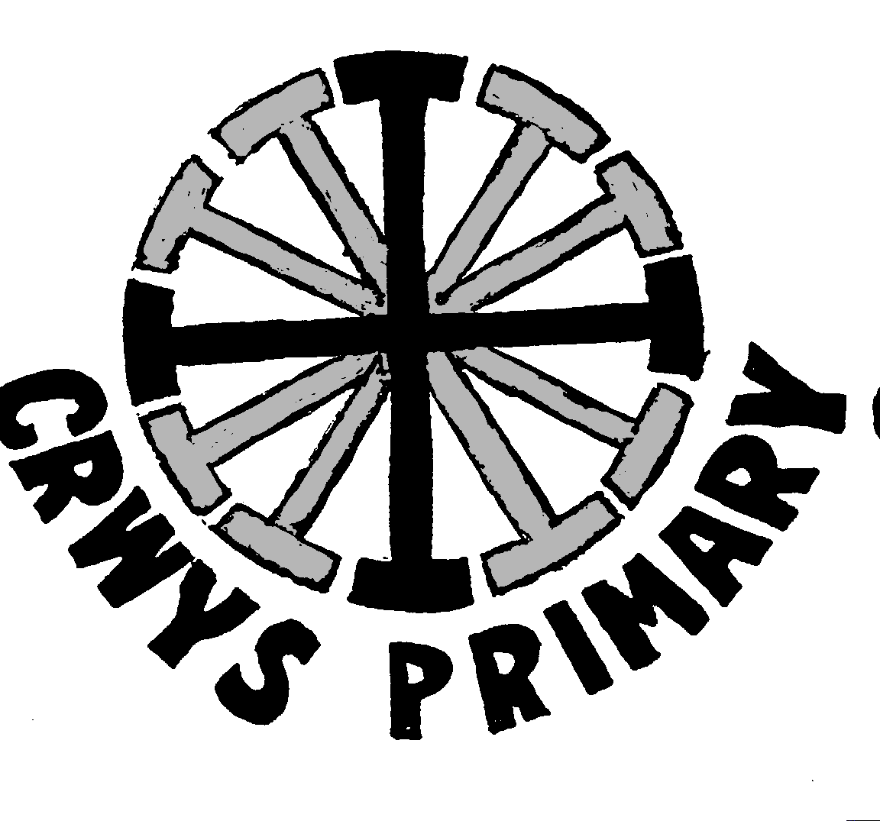
Chapel Road, Three Crosses, Swansea SA4 3PU

Headteacher: Mr. P.A. Withey e-mail:crwys.primary@swansea-edunet.gov.uk
( & Fax (01792) 872473



3rd September 2014

Dear Parent/Guardian

As we begin another school year I thought it may be useful to provide you with some information about the coming term.

This term Y5/6 will have the opportunity to go swimming on Mondays at Penyrheol Pool. In addition every Tuesday the class will have PE so please ensure your child has the appropriate change of clothing. A PE kit can be left in the class cloakroom during each half term. I would appreciate it if pupils could dress appropriately for these sessions for health and safety, as well as for reasons of hygiene. A letter will also be sent out this week outlining the extra-curricular clubs available to pupils.

A written maths worksheet, tables and spelling list will be set on a Monday to be completed by Friday. I am particularly keen for children to thoroughly learn their tables in this first half term.

Children are encouraged to read for at least 15 minutes every day and I will set a focused reading activity each weekend. In addition on a Friday the children will be given a weekend quiz which will comprise of topical questions and some that require a little research. It would be appreciated if pupils could keep homework activities in a file.

Each child will be provided with a blue berol ink pen. Pupils can use their own but I would ask that they are one of a similar specification.

School and class news can be found on our school website, class website (www.yearfivesix.yolasite.com) and Twitter.

During the first half term we will be studying the following:

English: Creative writing, recount and instructional writing.

Maths: Place value, 4 rules of number fractions, decimals, percentages, area, perimeter, volume and investigations.

Science: Forces, the human body and electrical circuits.

Welsh: Oracy and writing based on expressing personal preferences and past tense recount of basic events.

History: World War II

Art: Linked to topic work and seasonal issues.

PE: Swimming, games skills (netball, football, rugby) and health related fitness.

PSE/RE: Respect and topical festivals.

The first date for the diary is Tuesday 23rd September when will be visit the Dylan Thomas Theatre and Swansea
Museum to watch a play “The White Feather”. Further dates will be posted on our website.

Should you have any questions or concerns please contact me at the school or via my e-mail address
(staff-crwp6@crwys.swansea.sch.uk)

Yours sincerely

Simon Short
Deputy Headteacher

